Section A: Concept Application
QUESTION : 1
You are setting up a new database for the Zomato project. Which SQL command creates a new database called analytics_db ?
CREATE DATABASE analytics_db ;
USE analytics_db ;

ANSWER : ” The CREATE DATABASE command is used to create a new database. Here a database named analytics_db is created to store the Zomato project data”

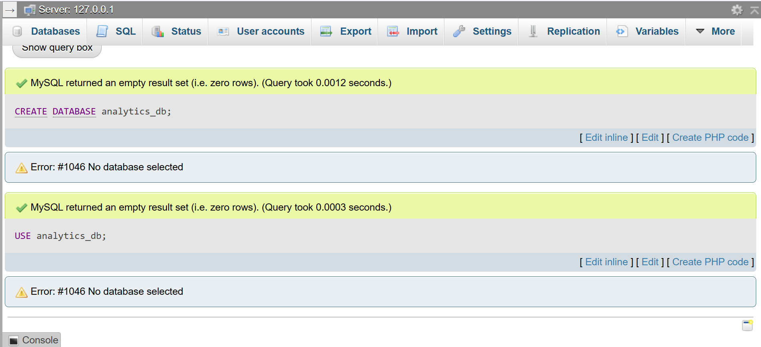
Explanation : The CREATE DATABASE statement is used to create a new database named analytics_db, which stores all project-related tables and data .
QUESTION : 2
You add a restaurant_id column to the restaurants table as its primary key. What is a primary key, and why must its values be unique ?

CREATE TABLE restaurants (
restaurant_id INT AUTO_INCREMENT,
restaurant_name VARCHAR(100),
location VARCHAR(100),
rating DECIMAL(2,1),
PRIMARY KEY(restaurant_id)
);
INSERT INTO restaurants (restaurant_id,restaurant_name,location,rating)
VALUES (101,'Dominos', 'Koramangala',4.5) , (102,'Pizza Hut', 'Indiranagar',4.3),
(103,'KFC', 'MG Road', 4.2) , (104,'Burger King', 'Whitefield',4.1) ,
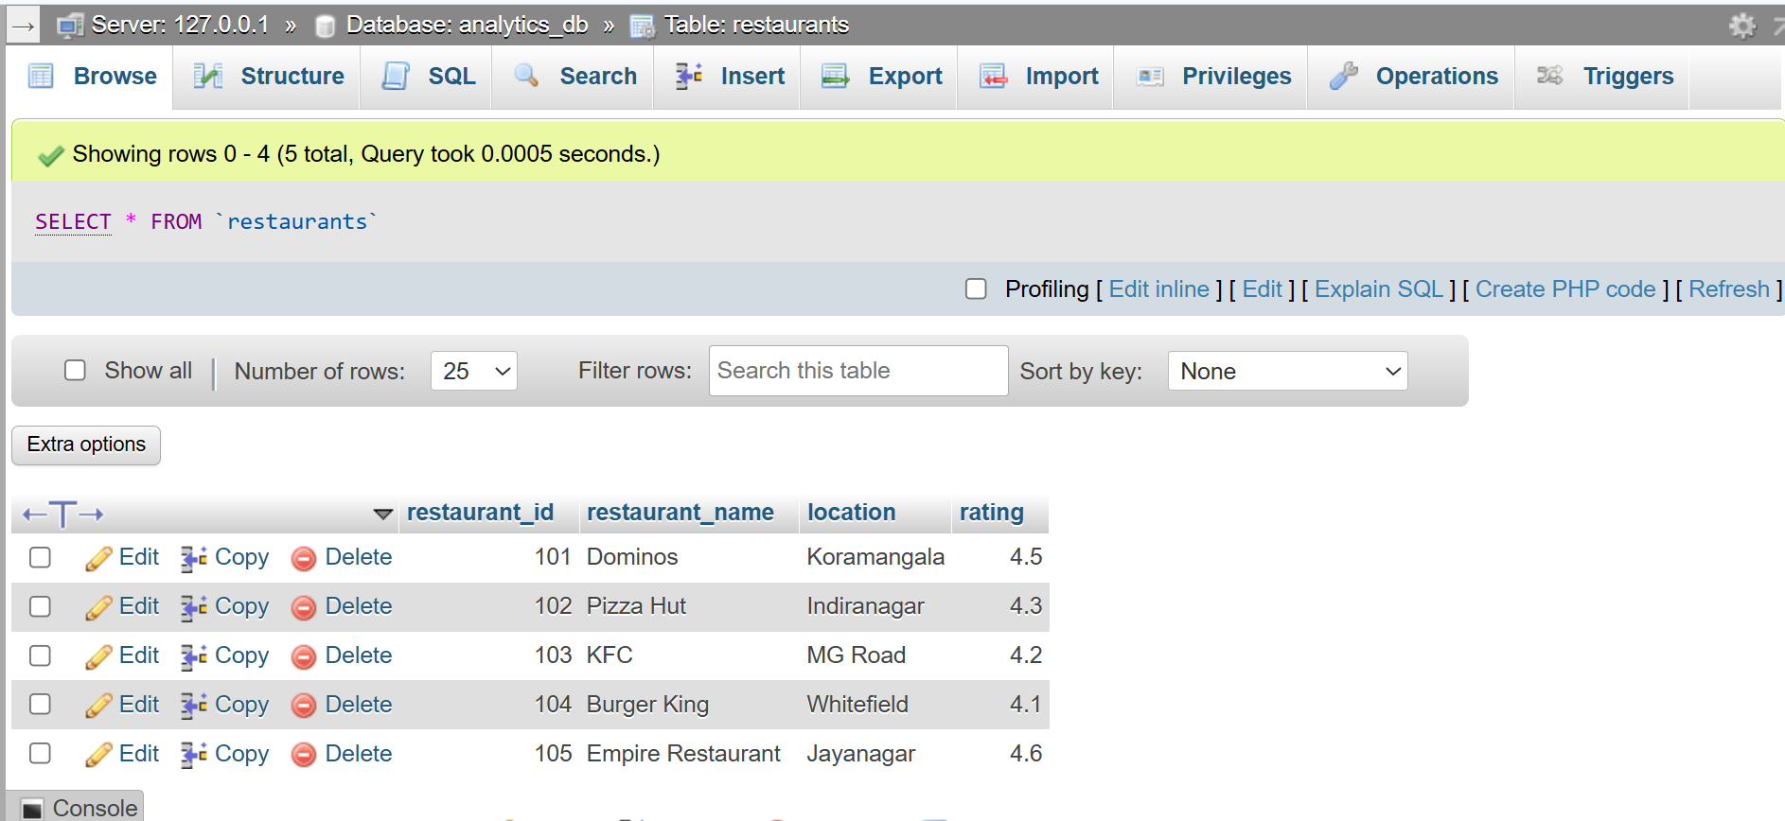
(105,'Empire Restaurant','Jayanagar', 4.6);
ANSWER : “ A Primary Key is a column that uniquely identifies each record in a table. It does not allow duplicate or NULL values, ensuring that every row has a unique identity ”

ERROR :
INSERT INTO restaurants(restaurant_id, restaurant_name, location, rating)
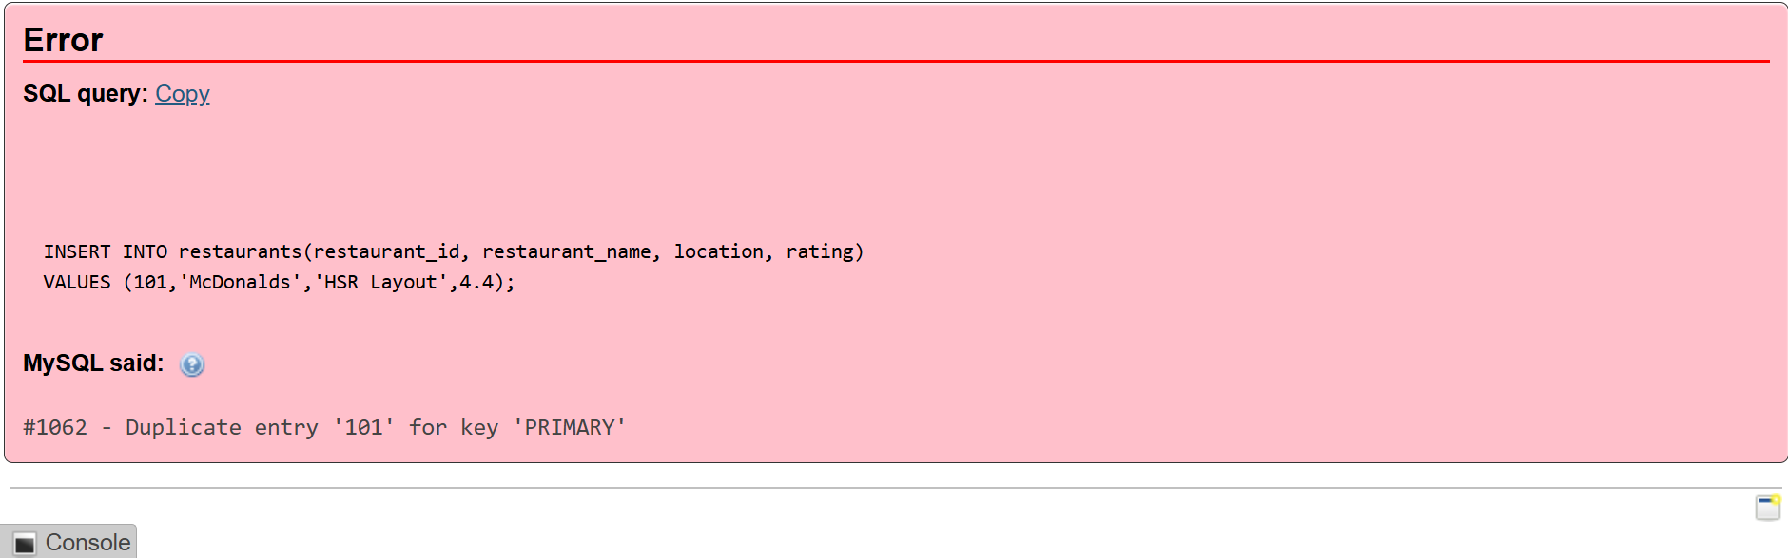
VALUES (101,'McDonalds','HSR Layout',4.4);
Output Explanation :
“ This error occurs because the restaurant_id column is defined as the Primary Key, and a Primary Key must contain only unique values. ”

QUESTION : 3
The ratings table references restaurant_id from the restaurants table. What is a foreign key, and what integrity rule does it enforce ?

CREATE TABLE ratings(
rating_id INT PRIMARY KEY,
restaurant_id INT,
customer_rating DECIMAL(2,1),
FOREIGN KEY(restaurant_id) REFERENCES restaurants(restaurant_id)
);

INSERT INTO ratings(rating_id,restaurant_id,customer_rating)
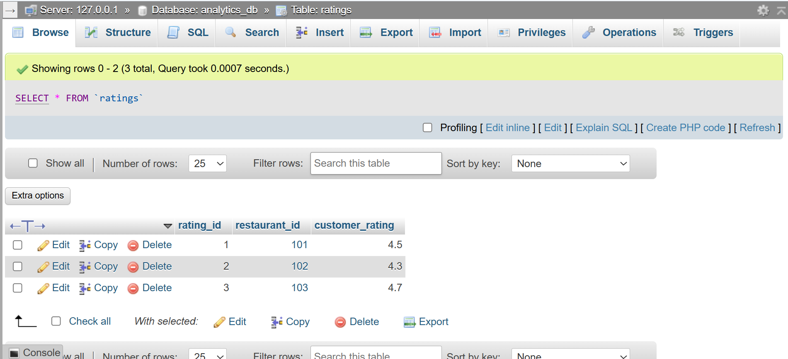
VALUES(1,101,4.5),(2,102,4.3),(3,103,4.7);
ANSWER : “ A Foreign Key is a column that references the Primary Key of another table. It creates a relationship between two tables and enforces Referential Integrity, ensuring that only existing values from the parent table can be referenced ”

ERROR :
INSERT INTO ratings (rating_id, restaurant_id, customer_rating)
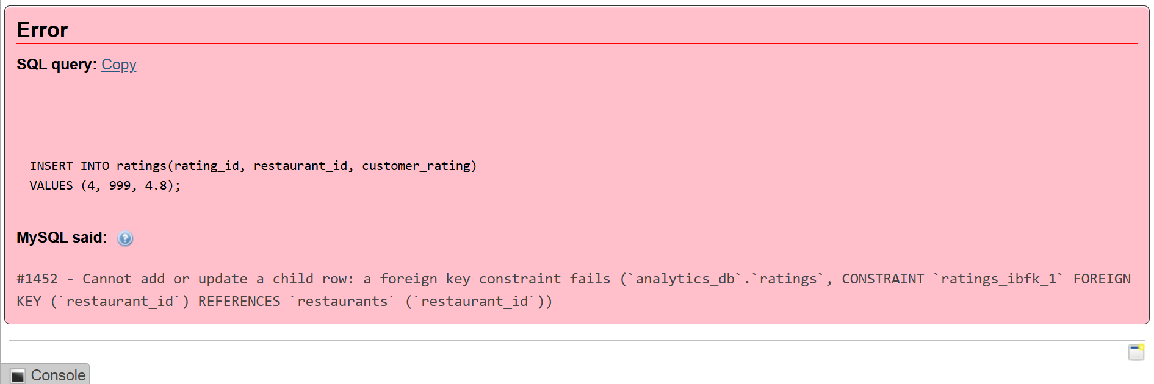
VALUES (4, 999, 4.8);
Output Explanation :
“ This error is a live example of Referential Integrity—the database rejected the rating insert because restaurant_id = 999 does not exist in the parent restaurants table ”

QUESTION : 4
You apply a NOT NULL constraint to the restaurant_name column. What kind of data entry does this constraint prevent ?

CREATE TABLE restaurant(
restaurant_id INT PRIMARY KEY,
restaurant_name VARCHAR(100) NOT NULL,
city VARCHAR(50)
);

INSERT INTO restaurant(restaurant_id,restaurant_name,city)
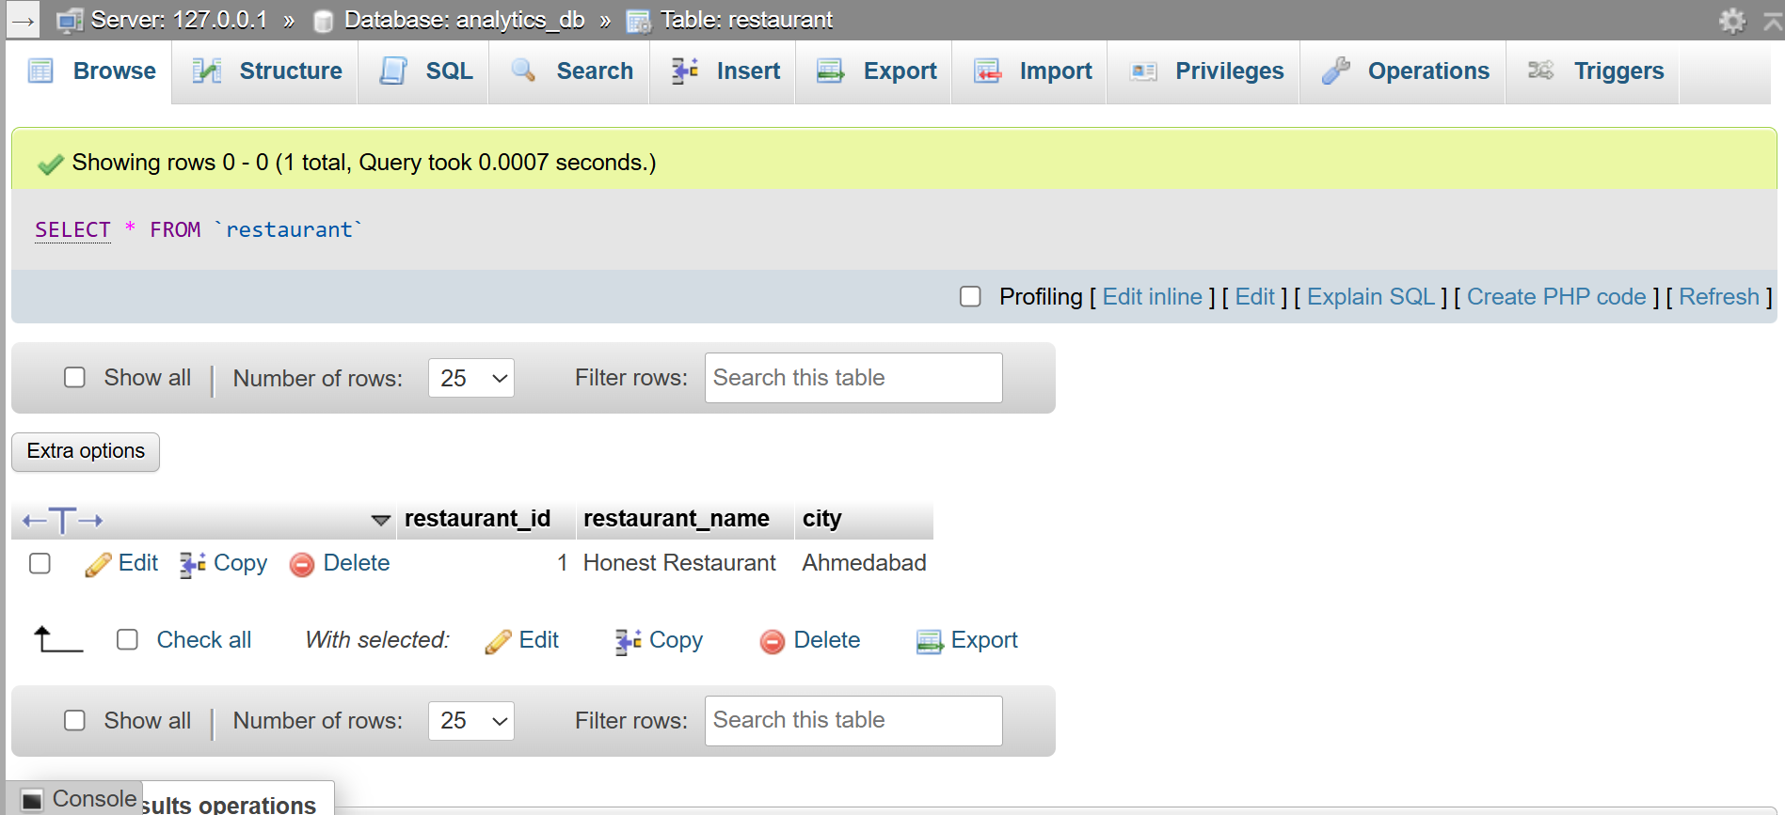
VALUES(1,'Honest Restaurant','Ahmedabad');
ANSWER : “ A NOT NULL constraint in SQL is a rule applied to a database column that mandates a valid value for every single row. It enforces data completeness by preventing users from inserting empty or NULL entries into essential fields ”

ERROR :
INSERT INTO restaurant(restaurant_id,restaurant_name,city)
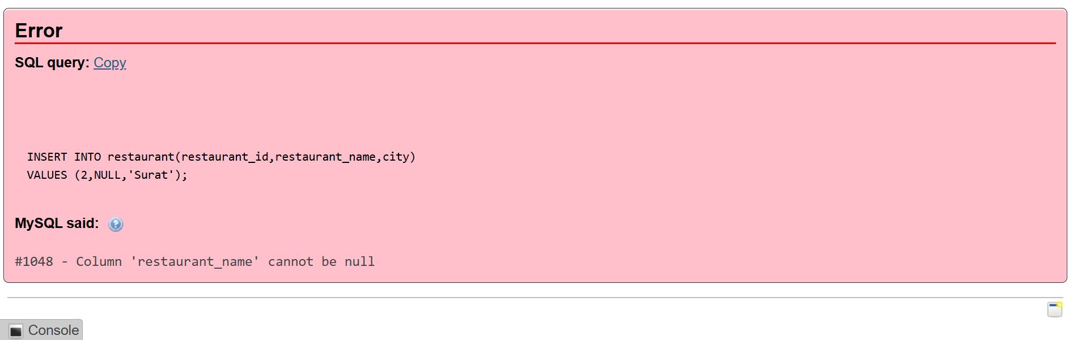
VALUES (2,NULL,'Surat');
Output Explanation :
“ This error occurs because the restaurant_name column has a NOT NULL constraint applied to it, making the name field mandatory for every record. When you tried to insert NULL into this column, MySQL blocked the action and rejected the invalid entry to ensure data completeness. To fix this, you must pass an actual text value for the restaurant's name instead of NULL “

QUESTION : 5
You draw an ER diagram before writing any SQL. What does an ER diagram represent in relational database design ?

ANSWER : “ An Entity Relationship (ER) Diagram is a visual representation of a database structure. It shows the entities (tables), attributes (columns), primary keys, foreign keys, and the relationships between tables before creating the database ”

Relationship :
One restaurant can have many ratings.
restaurant_id is the Primary Key in the restaurants table.
restaurant_id is the Foreign Key in the ratings table.
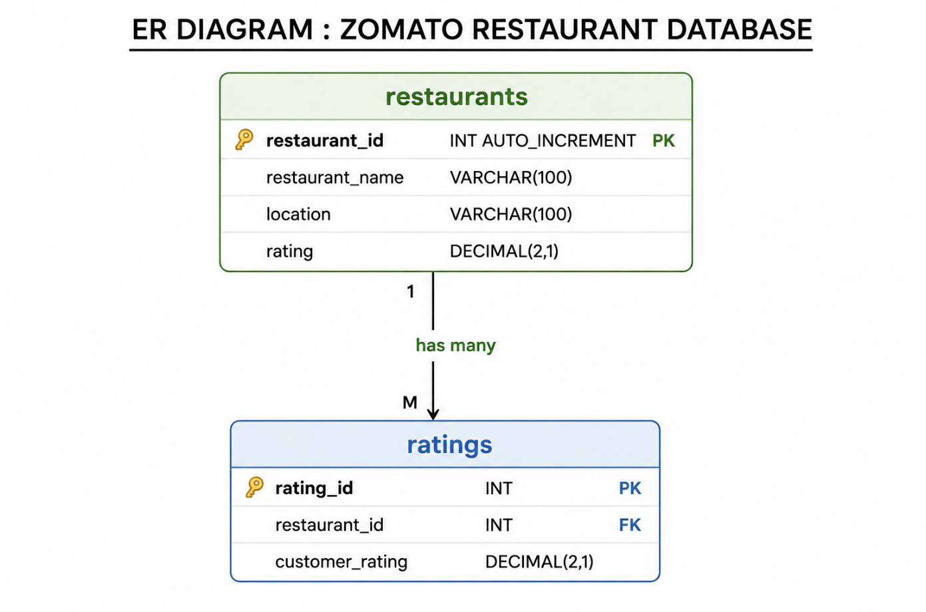
NOTE….. “ The rating column in the restaurants table stores the overall average rating of a restaurant, while the ratings table stores individual ratings given by different customers. This creates a One-to-Many (1:M) relationship, where one restaurant can have many customer ratings ”

PK = PRIMARY KEY
FK = FOREIGN KEY
1:M = ONE – TO – MANY RELATIONSHIPS

Explanation :
“ Entity Relationship (ER) Diagram is a visual representation of a database structure. It shows entities (tables), attributes (columns), primary keys, foreign keys, and the relationships between tables before implementing the database ”

